MAP
Possible Solutions to Exercises



Describe Objects

a) Interacting Objects
1. Show Interacting Objects
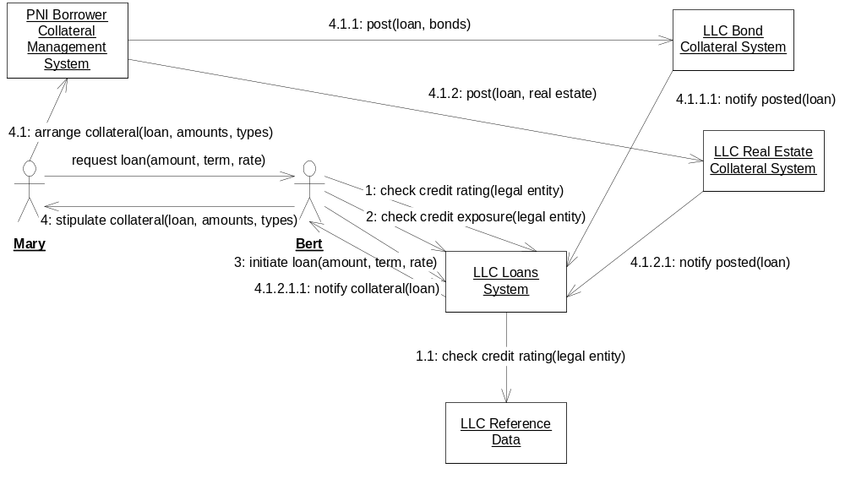
2. Kinds of Objects and Attributes Managed
Loans System:
- loan portfolio (including total credit exposure)
- loans (including principal, rate, term)
- reference to collateral posted
Reference Data System:
- legal entity hierarchy (parents and subsidiaries)
- credit ratings
Borrower Collateral Management System:
- obligations to provide collateral
- details of assets posted as collateral
- references to the relevant loans
Bond Collateral System:
- details of bonds posted as collateral
Real Estate Collateral System:
- details of real estate posted as collateral.
3. Polymorphic Type
Detailed handling of collateral types varies, but same operations are supported.
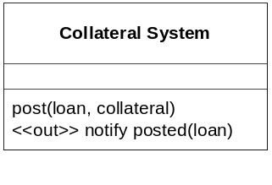

b) Find Multiple Types
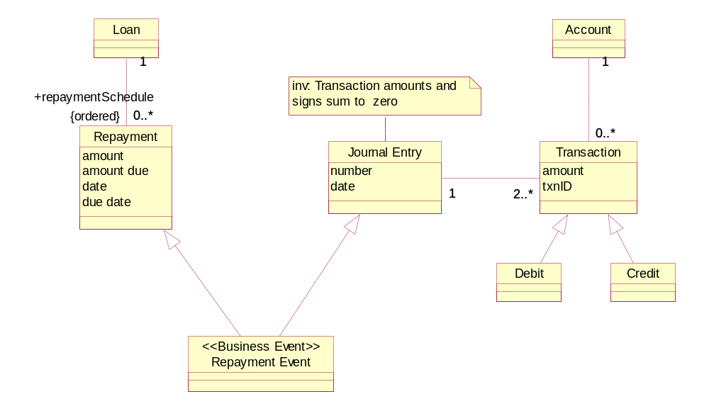
If a two or more aspects (types) of the behavior of a single underlying object are tracked by separate computer systems as though they are totally separate objects, serious inconsistencies typically arise. For example, in this case, the asset corresponding to the unpaid balance on a loan should be correctly reduced over time as repayments take place. There must therefore be communication between the loans system and the subledger system whereby the business event of repayment is converted into an appropriate journal entry and posted to the ledgers.

3.1 Objects, Snapshots
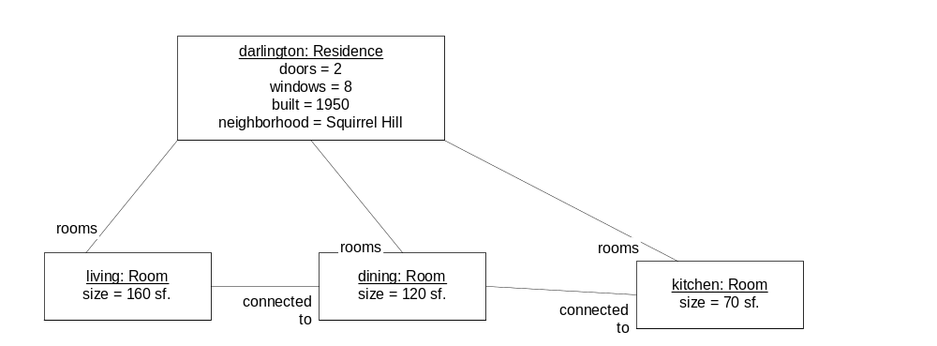

3.2 Information Model

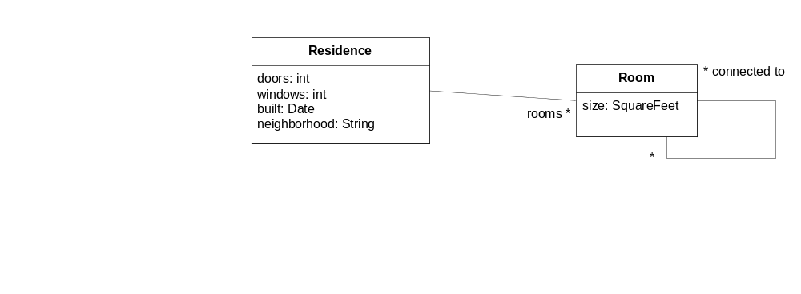

3.3 Snapshot Pairs
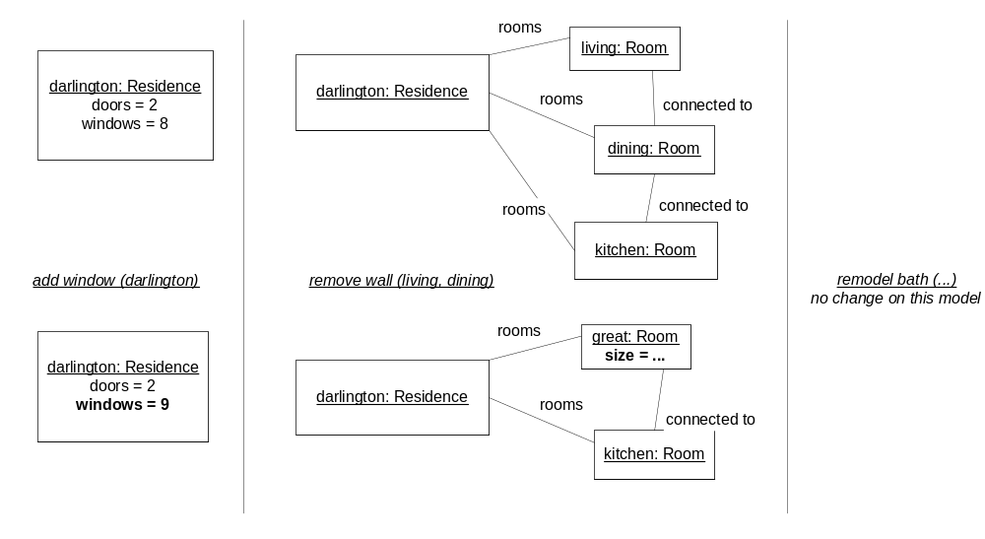

3.4 Actions

action add Window ( r : Residence)
description: the house is remodeled to add a new window to a residence
precondition: none
postcondition: the number of windows in the residence r is one greater than before

action remove Wall ( r1: Room, r2: Room)
description: the house is remodeled to join two contiguous rooms into one
precondition: the two rooms are connected to each other
postcondition: the rooms r1, r2 are gone. A new room, r3, is created and added to house rooms.
r3 is connected to all the rooms that r1 and r2 were connected to.
the size of r3 is the sum of the sizes of r1 and r2.

3.5 Scenarios with text and snapshots
Scenario name: new wing on mansion
Initial state: Titus is a contractor, Jake the homeowner
- titus and jake sign the contract
- titus lays the foundation
- titus raises the walls
- titus adds the roof
- titus and jake do the walkthrough
- jake adds the windows
- jake adds the doors
- jake adds the finished flooring
Final state: the new wing is complete

Snapshots: this would probably require new types of objects for Wing, Foundation, Roof, Wall.

3.6 Role Activity Diagrams
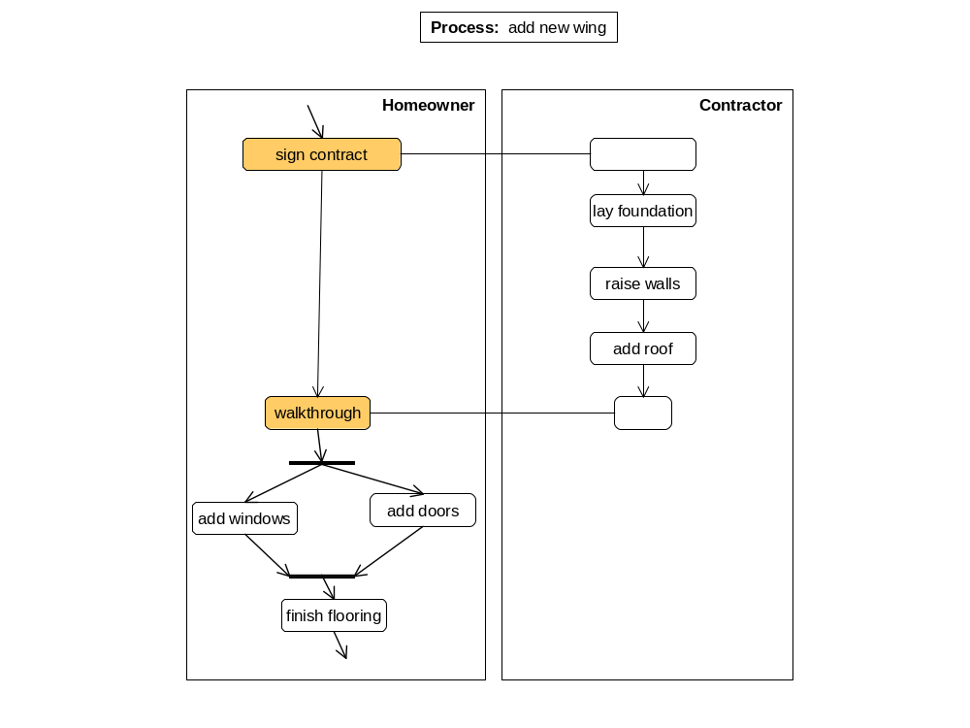

4.1 Draw Object Snapshots, Build Information Model from Snapshots. Understand Navigation Expressions.

Snapshots & User Interface
Note: information not shown in snapshot is simply omitted, rather than lost.
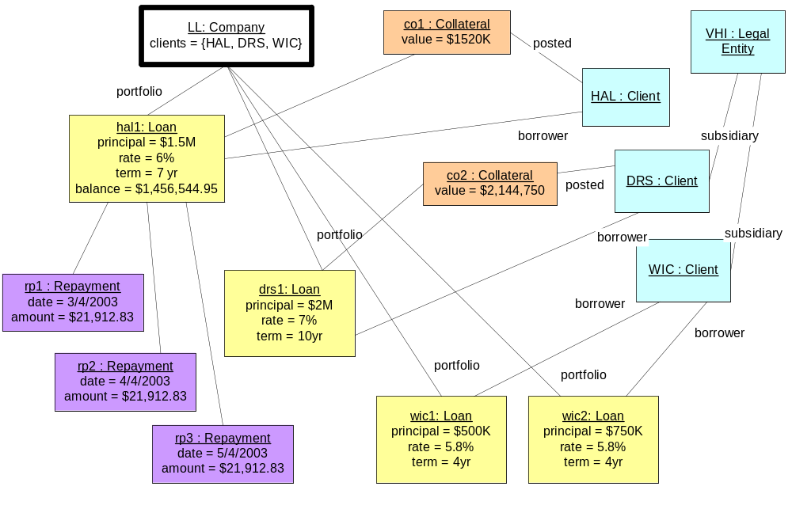

Creation:
  - Legal Entity: When any kind of legal entity becomes known to the company in any capacity;
  - Client: When the company gets a new client;
  - Loan: When the terms of a new loan are agreed between the company and a client;
  - Collateral: When collateral is posted by loanee;
  - Repayment: As soon as the repayment is either scheduled or made.

Build Information Model from Snapshots
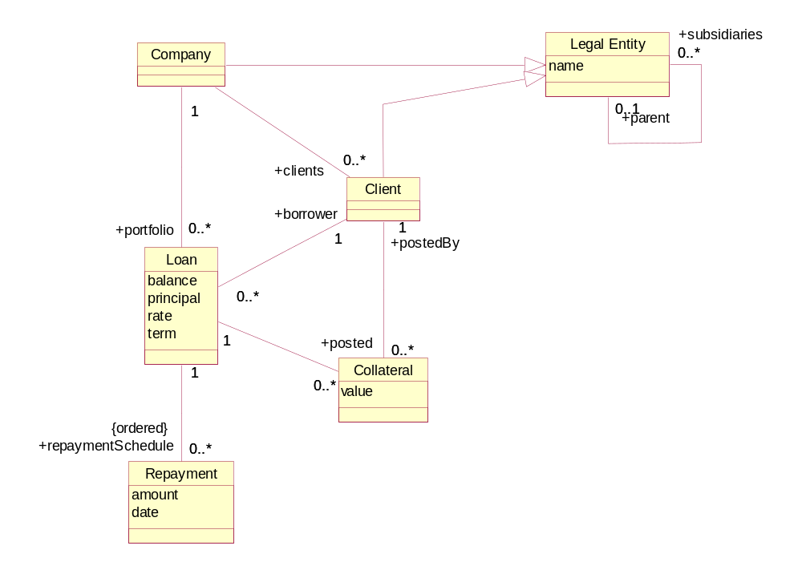

(c) Interpret Navigation Expressions
- LL.portfolio.borrower = {HAL, DRS, WIC}
- LL.portfolio → select(principal > $750K).borrower = {HAL, DRS}
- LL.portfolio → select(l | l.collateral->IsEmpty) = { wic1, wic2 }
- hal1.repaymentSchedule → sum(amount) – (hal1.principal – hal1.balance) = $22,283.45
- The borrowers who are subsidiaries of some parent LE = { DRS, WIC }
- The clients who do not have any loans = {}

(d) Write Navigation Expressions
- Informal: All repayments made to LL.
Formal: LL.portfolio.repaymentSchedule
- Informal: Legal Entities who are parents of borrowers.
Formal: LL.portfolio.borrower.parent
- Informal: The interest rates on loans in the portfolio
Formal: LL.portfolio.rate

4.2 Convenience Attributes. Invariants. Supertypes.

a) Introduce convenience attributes
- The total credit exposure for a Company, across its entire portfolio of Loans.
Company
creditExposure : USD
- Assuming a “due date” attribute on Repayment, the number of days by which a Repayment on a Loan is overdue at the present time.
Repayment
age : Days
- The Repayment amount outstanding on a Loan, across all overdue Repayments for that Loan. Assume the existence of an “amount due” attribute on Repayment.
Loan
arrears : USD
- The amount of principal repaid for a Loan.
Loan
principalRepaid : USD

b) Write Invariants

i. Derivation Invariants for Convenience Attributes
- The total value of the collateral posted for a Loan
Loan inv : totalCollateral = posted → sum(value)

- The total credit exposure for a Company, across its entire portfolio of Loans.
Company inv : creditExposure = portfolio → sum(balance)

- Assuming a “due date” attribute on Repayment, the number of days by which a Repayment on a Loan is overdue at the present time.
Repayment inv : if Date.now > dueDate then age = Date.now – dueDate else age = 0
- The Repayment amount outstanding on a Loan, across all overdue Repayments for that Loan. Assume the existence of an “amount due” attribute on Repayment.
Loan inv : arrears = scheduledRepayments → select(age > 0) → sum(amountDue)
- The amount of principal repaid for a Loan.
Loan inv : principalRepaid = principal – balance

Note that availability of this attribute would have simplified the expression in the answer to 4.1(c)4 above.

ii. Extra Model Constraint
Informal: A Borrower from a Company is necessarily a Client of that Company.
Formal: Company inv : self.clients → includesAll(self.portfolio.borrower)
Equivalent set expression: self.portfolio.borrower ⊆ self.clients.
Note that this invariant is required to make sense of the cyclic associations between Company, Client and Loan.

c) Utilize Supertypes
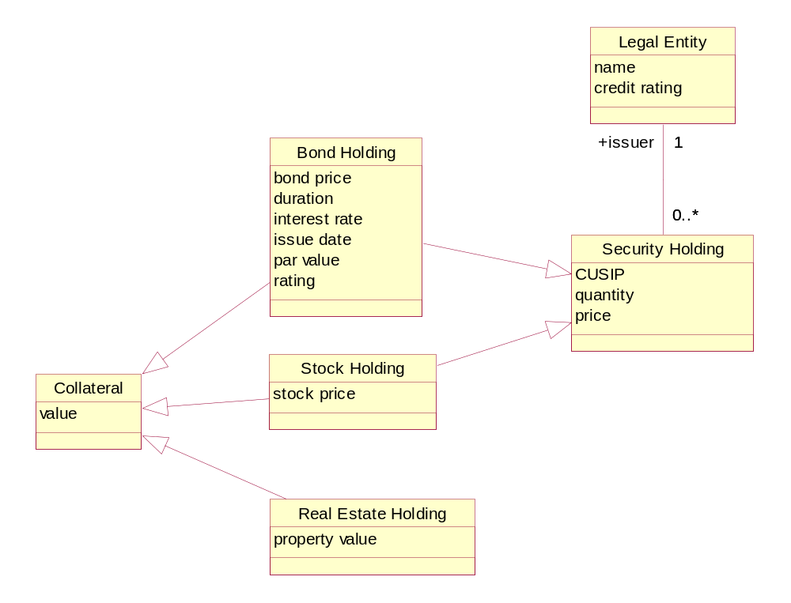
Invariant on Bond Holding: rating is the same as the issuer’s credit rating
There are different types of collateral: Stock Holding, Bond Holding and Real Estate Holding.
The supertype is Collateral.
In addition, Stock Holding and Bond Holding are both types of Security Holding.
The generic attribute Collateral::value puts a USD value on a collateral holding. Each subtype has its own valuation attribute: BondHolding::bondPrice; StockHolding::stockPrice and RealEstateHolding::propertyValue, whose value is determined using a procedure (whether manual, semi-automatic or full automatic) specific to that type of holding. For SecurityHoldings, the Collateral::value requires further computation to multiply the respective price attribute by the SecurityHolding::quantity attribute.

4.3 Define Scenarios and Snapshot Pairs.

(a) Scenarios and Snapshot Pairs
- the long-lived activity could be: complete a loan
starts – when HAL requests a loan from LLC.
ends – when HAL has completed all the scheduled repayments on the loan.
- the finer grained actions could be: request loan, agree amount, offer term, agree term, offer rate, agree rate, post collateral, activate loan, draw down, make repayment.
the type could be: Loan.
the states could be: proposed, active, closed.
- scenario: HAL borrows from LLC and then pays off the loan
initial state: HAL is not a subsidiary of any other legal entity. It has a credit rating of BBB.
scenario steps
- HAL requests a loan for $1.5M over 8 years from LLC.
- LLC offers a rate of 6%, and counter-proposes a term of 7 years.
- HAL agrees to the amount, rate, and term.
- LLC stipulates to HAL that collateral must always be greater than or equal to the balance outstanding on the loan at any given time.
- HAL agrees and posts initial collateral of $1520K.
- LLC schedules all 84 repayments and activates the loan.
- HAL draws down the full loan amount.
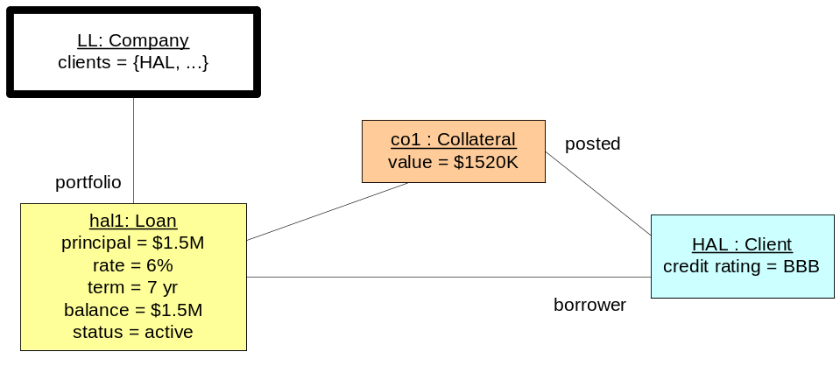
- HAL makes the first monthly repayment of $21, 912.83 on 3/4/2003.
- HAL makes the second monthly repayment of $21, 912.83 on 4/4/2003.
- HAL makes the third monthly repayment of $21, 912.83 on 5/4/2003…
- HAL makes the 84th monthly repayment of $21, 912.83 on 2/4/2009.
final state: HAL’s loan with LLC has a balance of $0, and is closed.
- after step 3 – hal1 has a principal of $1.5M, a rate of 6% and a term of 7 years, the balance
is $0 and status is “proposed”.
after step 7 – collateral of $1520K has a new link to hal1 and a new link to HAL, the balance
equals the principal at $1.5M, and status is “active”.
after step 91 – the full set of 84 repayments is in place and linked to hal1; the balance is
reduced to $0 and status is “closed”.
- possible interference or exceptions
HAL’s credit rating is downgraded, resulting in a requirement for more collateral and/or adjustments to other loan parameters; e.g., interest rate, term.
HAL fails to make timely repayments, loan is foreclosed, and collateral is seized by LLC
Collateral asset value falls, resulting in need for posting of further collateral
HAL files for bankruptcy, increasing the risk that the loan will become a bad debt.

(b) Specify an Action
- informal description for post-conditions
drawDown
postcondition: the balance on the loan equals the principal (which remains unchanged)

scheduleRepayments
postcondition: a set of monthly scheduled repayments amortizing the principal over the
term at the agreed rate is associated with the loan

makeRepayment
postcondition: the repayment amount and date are filled in and the balance on the loan
is reduced by the amount determined by the amortization schedule

- add parameters and clean up description
drawdown (ln: Loan)
postcondition:
-- the balance on the loan equals the principal (which remains unchanged)
ln.balance = ln.principal and ln.principal = ln.principal@pre

scheduleRepayments (ln: Loan, firstRepaymentDate : Date)
postcondition:
-- A set of monthly scheduled repayments amortizing the principal over the
-- term at the agreed rate is associated with the loan.
-- (Assume existence of necessary amortization and date functions.)
let amountDue be amortizedRepayment(ln.principal, ln.rate, ln.term) and
numRepayments be 12 * ln.term in
ln.repaymentSchedule→size == numRepayments and
ln.repaymentSchedule→forall(r | r.amountDue = amountDue) and
ln.repaymentSchedule→dueDate =
dateSequence(firstRepaymentDate, Month,
numRepayments)

makeRepayment (r: Repayment)
postcondition:
-- The repayment amount and date are filled in and the balance on the loan
-- is reduced by the amount determined by the amortization schedule.
-- Assume existence of a “principalRepaid” convenience attribute on
-- Repayment.
r.amount = r.amountDue and r.date = Date.now and
r.loan.balance -= r.principalRepaid
-- Note that this post condition could have been simplified by defining an invariant
-- forcing the balance to be in line with the principal repaid by all repayments
-- made.

- add pre-conditions
drawDown (ln : Loan)
precondition:
-- the loan has been designated as active by the lender
-- and the repayment scheduled has been established
ln.active and ln.repaymentSchedule → NotEmpty

scheduleRepayments (ln: Loan, firstRepaymentDate : Date)
precondition:
-- Principal, rate and term have been agreed
ln.principal <> 0 and ln.rate <> 0 and ln.term <> 0

makeRepayment (r: Repayment)
postcondition:
-- None.
true

5.1 Define Business Goals and Architecture

Model Business Goals
  - These concepts are mentioned in the goals/requirements, and so must be formalized. This can be done in the business information model that accompanies the goal model. Refer back to the information model in 4.1b to provide context for the following bullet points.
    - The interest paid per loan to date can be formalized as a convenience attribute on Loan, and figured by summing over the interest repaid on all the repayments made so far.
    - Projected interest can be computed for a given future time period for a loan by summing over the interest element of the relevant scheduled repayments.
  - The top level goal may be stated in one of the following equivalent ways:
- Minimize risk while maximizing revenue;
- Maximize the revenue/risk ratio;
- Minimize the risk/revenue ratio.
Why-how analysis might yield goals like:
- Have accurate risk information
  - Use projection model for risk
  - Continuously tune risk projection model from past history
- Adjust projected revenue with bad-debt history
  - It cannot be objectively measured. While the credit exposure itself can be defined and objectively measured, the minima that might be achieved within any given future time frame cannot be predicted. Consequently, “minimize” and “maximize” goals are often called “soft goals”. Despite their “softness”, they have an important place in goal modeling.
  - The lending activities and attributes will be fully defined once the Business Architecture (processes, roles, activities, information model) has been completed. Sometimes further detail is added in the Application Black Box Architecture (use cases and information model). Hence, the activities that can be constrained, and the attributes cited in the constraints, will be definable in a retrospective pass over the Business and Application Black Box Architectures once they are both largely complete.
  - Architectural styles should be used early on to define the concept of a constraint generically.
- The concrete and abstract syntax for constraints can be defined with the aid of architectural styles. For example, the syntax and semantics of a limit constraint on an activity can be defined generically with placeholders for the activities and attributes being constrained.
- Business process exception patterns can be defined to specify precisely how business processes should react to differing severities (minor, serious, fatal) of exception arising out of constraint violation. It is a best practice to define these as building blocks for construction of the Business Architecture.
  - The goal of optimizing lending activities is the higher level goal.
  - Answer #2 above offers a more precise statement of what might constitute optimization of lending activities.
  - These could be reporting use cases to allow drilling up/down the loan, client and legal entity hierarchies looking at total credit exposure, revenue (actual and projected). Drill-down into collateral assets and values would also help. The use cases should support plugging in of different hypothetical values to drive results.
  - There is no magic bullet. The following process would yield a rational solution.
- Find out if there really is a conflict. What does “notify immediately” mean in quantitative terms?
- If more timely information truly is not available, assess the risk that would result from a less-than-immediate availability of information.
- Fashion a compromise. For example, provide daily reports that include notice of client credit downgrades, but also arrange to trigger extra reports intra-day if a downgrade occurs more than a certain amount of time earlier than end of day.
- Get explicit agreement from stakeholders to any such compromise, and document it with the original conflict within the goals model.
- Provide traceability back from use cases and information model to the conflict within the goals model so the rationale for the compromise functionality can be reviewed and validated.

Build Role Activity Diagram
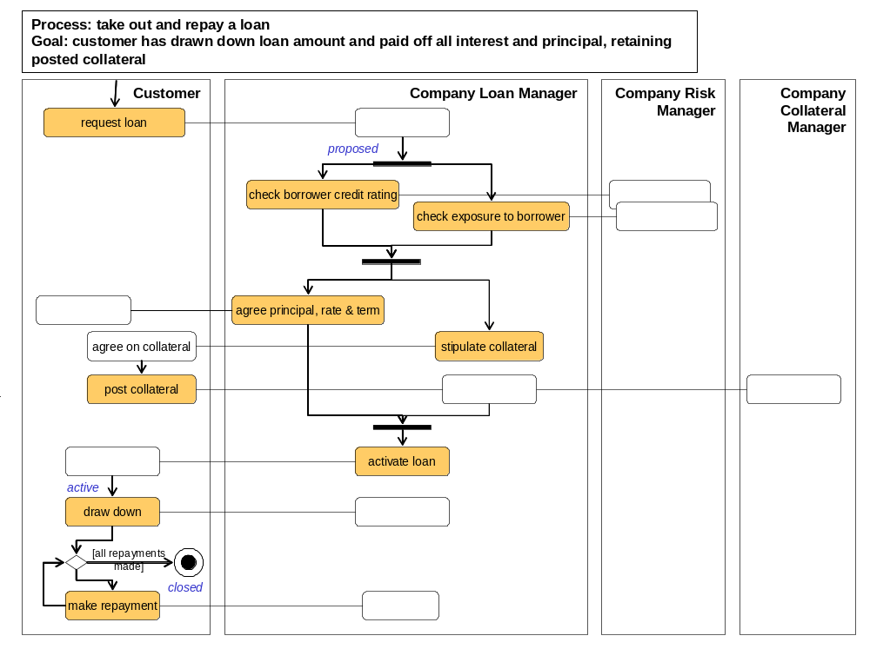Notes: the RAD above focuses on main flow, and makes some simplifying assumptions as follows.
- The full loan amount (principal) is always drawn down in a single operation.
- The case of late or absent repayments leading to foreclosure is not shown.
- Numerous other contingencies, such as variation in collateral value, loan interest rate changes, etc., have been omitted.
- This model does not deal with the lending of further amounts followed by further drawings and consequent adjustments in repayment schedule, except in the form of taking out an entirely new loan.
2. Activity Specifications
activity: post collateral
roles: Company, Client
inputs: loan: Loan, collateral: Collateral from Client
outputs: none
precondition: loan is proposed, and collateral amount has been stipulated by lender
postcondition: collateral in the required amount has been posted against the loan

activity: draw down
roles: Company, Client
inputs: loan from Client – loan from which to draw down
outputs: cash: USD for Client
precondition: the loan is active.
postcondition: the balance equals the principal, which is unchanged from before

- Information Model
The types and attributes have business meaning and are not specific to a software system.

Client The party who borrows.
Collateral Assets belonging to the Client, which can be transferred in whole or in part to the Company in the event that a Loan is foreclosed.
Company The party who lends.
Legal Entity Any legally incorporated enterprise.
Loan The record of the funds advanced to the borrower and the history of repayment.
Repayment One of the scheduled transfers of funds from Client to Company to reduce outstanding balance and interest.
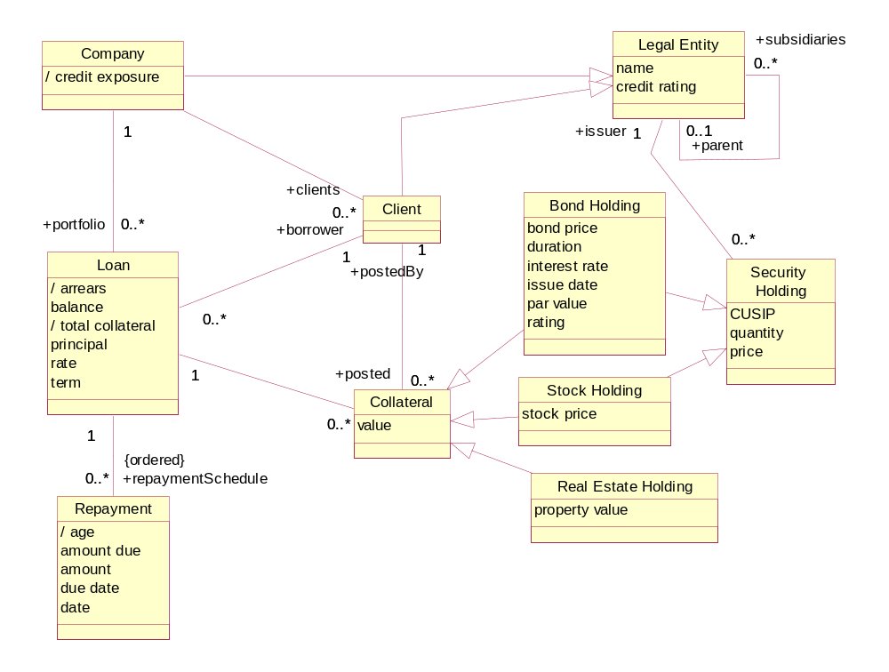

Build a State Diagram & Definition Matrix

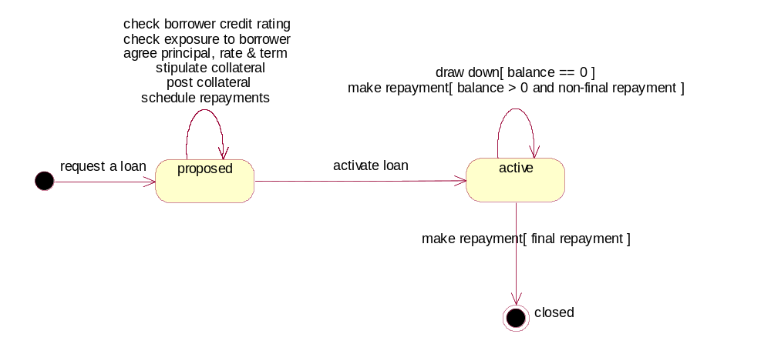
Note1: Since there are many activities that take place within state “proposed” it might be worth considering some interesting sub-states of that state.
Note2: This front-loaded complexity is typical of loans; there is a lot more work to do before a loan is activated than there is once funds are drawn down and repayments begin.

State → | initial | proposed | active | closed
Event ↓
Request a loan | proposed | NA | NA | NA
Check borrower credit rating | NA | proposed | NA | NA
Check exposure to borrower | NA | proposed | NA | NA
Stipulate collateral | NA | proposed | NA | NA
Post collateral | NA | proposed | NA | NA
Agree principal, rate, & term | NA | proposed | NA | NA
Activate loan | NA | active | NA | NA
Draw down | NA | NA | active | NA
Make repayment | NA | NA | active, closed | NA

State | Definition
proposed | balance == 0 and no repayments made
active | balance > 0
closed | balance == 0 and one or more repayments made

6.1 Use Case Specification

1) use case diagram
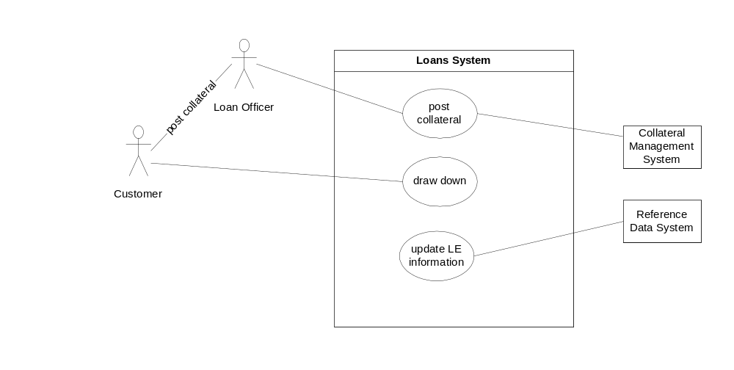

2) Black Box Information Model

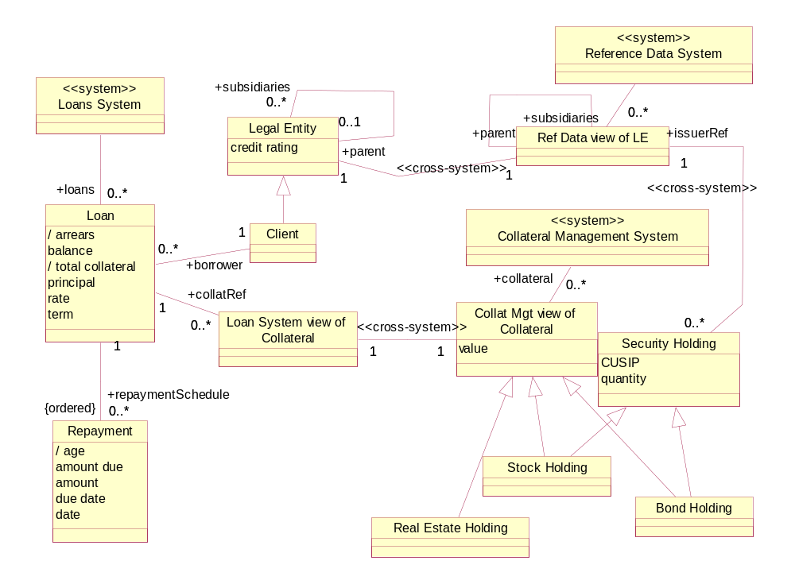
Notes:
- Some cross-system associations are necessary to relate different types, or differing views (projections) of the “same” types between systems, to ensure that they remain consistent.
- Examples given here are:
  - Loans and Reference Data occurrences of Legal Entity to be kept in synch;
  - At a later stage we might be able to dispense with LE altogether in Loans and maintain only Client, synchronizing it directly with LE within Reference Data on a regular basis;
  - Every Security Holding in Collateral Management to refer to an Issuer Legal Entity within Reference Data;
  - Collateral occurrences within Loans and Collateral Management to be kept in synch. (An alternative would have been to treat Collateral as being the responsibility entirely of Collateral Management.)

3) use case specifications

Use case: post collateral
Actors: Loan Officer, Loans System
Inputs: Loan, Client, list of assets (obtained from Client representative) to be posted as collateral for Loan
Outputs: Confirmation of posting
Trigger: Client contacts LLC offering assets as collateral against loan
Precondition: Loan is “proposed”; client offering collateral is client for Loan; collateral fulfils general criteria for suitability.
Postcondition:
If the collateral offered is sufficient, the offered collateral extends the set of holdings already in use as collateral against loan. If collateral is insufficient, there is no change to the system.

Use case: draw down
Actors: Client, Loans System
Inputs: Loan, specified by Client
Outputs: Notice of funds transfer initiation
Trigger: Client initiates automated draw-down process
Precondition: Loan is “active” and balance is zero
Postcondition: Loan balance equals principal, which remains unchanged, and funds transfer has been initiated

Use case: update LE info
Actors: Loans System, Reference Data System
Inputs: None.
Outputs: None.
Trigger: Daily synchronization schedule.
Precondition: true
Postcondition: Systems are synchronized in two directions such that
- every instance of Legal Entity in one system has a corresponding instance in the other system
- every instance of a parent/child link in one system has a corresponding instance in the other system.

6.2 Describe Steps and Alternate Paths

Use case: post collateral
Actors: Loan Officer, Loans System
Inputs: Loan, Client, list of assets (obtained from Client representative) to be posted as collateral for Loan
Outputs: Confirmation of posting
Trigger: Client contacts LLC offering assets as collateral against loan
Precondition: Loan is “proposed”; client offering collateral is client for Loan; collateral fulfils general criteria for suitability.
Postcondition:
If the collateral offered is sufficient, the offered collateral extends the set of holdings already in use as collateral against loan. If collateral is insufficient, there is no change to the system.
Main (success) steps:
- Client sends collateral asset list to loan officer.
- Officer looks up loan in system to validate:
    - That it exists and has been proposed;
    - that client offering collateral is the client for the loan.
- System remembers loan number for use as input parameter on posting.
- For each item on the list of assets:
    - officer looks up value of asset in loan system;
    - loan system obtains asset valuation from collateral management system;
    - loan system adds value of asset to posting total.
- Officer checks that posting total is not less than total valuation claimed by client.
- Officer OKs posting of assets to the system.
- Loans system informs collateral management system that collateral has been posted.
- Loans System confirms posting.
Alternate paths:
1a: Collateral list fails general suitability criteria.
1a1. Officer contacts client and explains problem.
2a: Loan in incorrect state.
2a1. Officer attempts to diagnose how error arose.
2b: Client mismatched.
2a1. Officer attempts to diagnose how error arose.
4iia: Asset cannot immediately be valued (e.g., real estate, or system unavailable).
4iia1. Asset valuation request is put in queue in collateral management system.
4iia2. Use case suspended pending valuation.
4iia3. Collateral management system reports back when asset valued.
4iia4. Resume at 4iii.
5a: Collateral insufficient.
5a1. Officer saves entered data, and contacts client to explain problem.
5a2. Client offers further collateral.
5a3. Resume at 5.

6.3 Identify & Specify Use Case Operations
Use case: post collateral
Operations from steps
- ….
- Officer looks up loan in system to validate status and client
- ….
- For each item on the list of assets:
    - officer looks up value of asset in loan system;
    - <<out>> loan system obtains asset valuation from collateral management system;
    - ….
- ….
- Officer OKs posting of assets to the system.
- <<out>> Loans system informs collateral management system that collateral has been posted.
- ….

6.4 Black Box Ports and Assembly

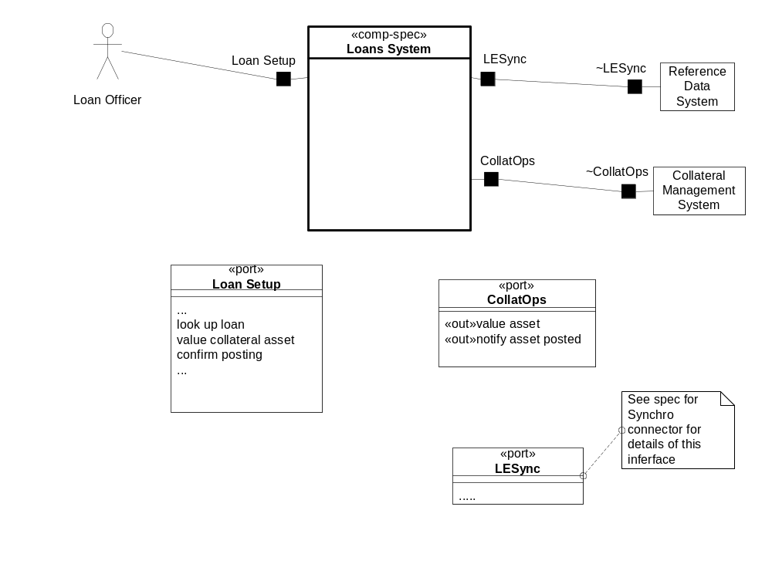

7.1 Draft Core Type & Use-Case Based Components

find core type components
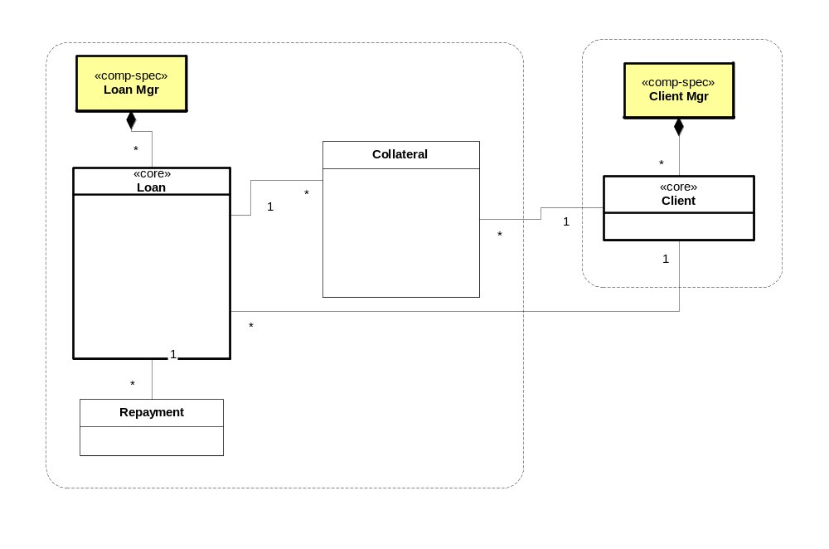

add use-case based components
Note: These can be separate interfaces of a single use-case component, particularly if using a generic workflow-like co-ordinator.
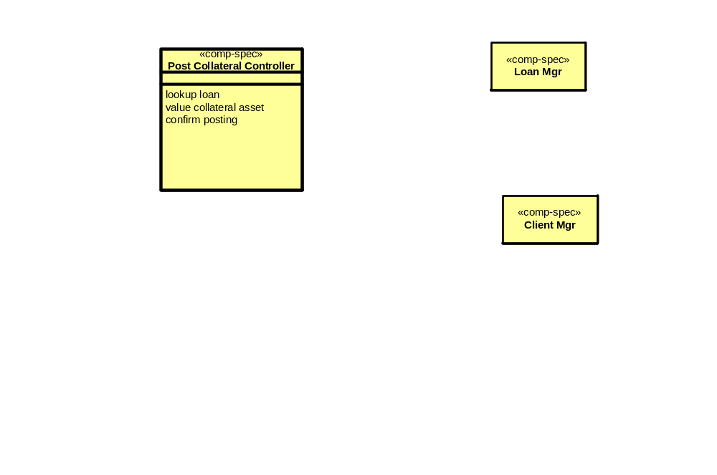

Appendix Exercise 1: UML Models
Instructor Example
- object snapshot – describes some objects, relationship values, attribute values
- class diagram – describes structure & constraints
- use case diagram – describes interactions between actors, systems
- sequence or collaboration diagram – describes interactions between objects
- state diagram – describes states & changes the object undergoes
- package diagram – describes structuring of models and work
- deployment diagram – describes nodes, applications, programs, etc.
- pattern – describes recurring design and its application

Internet Portal Case Study – “MAP Light”

Business Architecture
Note: this business architecture shows a bit more system-oriented properties than normal.
Types | Attributes, description
Invite | Invitees, event,
Calendar | Collection of events (do events overlap?)
Email message | Relevant because invite is delivered via email message. Attributes: email address, subject, content, attachment
Email system | Inbox, outbox
InviteResponse | Yes, No, Maybe + message, Invitee
Invitee | Is this really a kind of contact?
Host | Member of the portal
Location | Postal address
Directions | Text and graphical description of how to get from some location to another location (perhaps contact.address to event.location)
Event | Description, date/time range, location
AddressBook | Collection of contacts
Contact | Email address, postal address, phone numbers, notes, isPortalMember
SavedLocations
PortalAccount | SavedLocations, Contacts, Calendar, Invites, Email system

Scenario
Name: Celebrate USA even still playing in World Cup party
Description: Party at The Hogs Head with all students to celebrate Bruce Arena
Initial state: George is a member of MegaPortal. Martin and Ian are too, but Chris and Sean are not. Martin and Chris are in George’s contact list but the others are not. The Hogs Head is on George’s list of locations.
- George opens the MegaPortal page for Invites on Monday.
- George creates a new Invite, specifying that it will take place at the Hogs Head on Friday at noon. He adds Martin and Chris to the list of attendees from his contacts list. He also adds Sean and Ian to the invite, causing them to be added to the contact list.
- The system sends out an email to all the invitees giving the description of the event, a link to the MegaPortal page for this invite, and an attachment with map of the event location.
- Chris receives the email, follows the link, and issues his “No” answer, noting that he will be having a liver transplant that day.
- Ian receives the email, follows the link, and accepts the invite. Since he is a member of MegaPortal, this event is put onto his personal calendar.
- Sean receives the email, follows the link, and reports “Maybe”. He notes that he has a potentially reschedulable dentist appointment.
- Martin receives the email, follows the link, and reports “Yes”. Since he is a member of the MegaPortal, the event is added to his calendar. He requests customized directions from his saved work address to the event.
- George checks the status of the Invite and finds two Yes, one No, and one Maybe.
- On Friday morning the system sends out reminder emails to the Yes and Maybe invitees (not Chris).
- On Friday, the party happens and the Invite is marked as complete by the system.
Final state: The Invite is complete, emails have been sent to all participants and responses have been recorded by the system.

Action | Description
Create invite | List of attendees is collected, event is scheduled, invitees are optionally added to the contact list, and email is sent to all invitees
Respond to invite | Response of Yes, No, or Maybe plus message is recorded. If respondee is a member then his calendar is updated with this event. An email confirming is sent to the event host.
Check invite status | Boring
Send reminder email | By default, the day of the event, the system sends reminder emails to all invitees who have responded Yes and Maybe.
Deactivate invite | The invite is marked as complete after the end of the event

Black Box Architecture
Use Case Name | Business Trigger and Source | External Actors | End/Success Goal
Create Invite | Host/PortalMember request | Non-Member Invitees, Member Invitees, Calendar system, Email System, Contact System, Location System, Memberships | Invite sent to all invitees via email, Portal page for this invite, event added to host’s calendar
Respond to Invite | Invitee visits website via link | None | Status of the invite updated with InviteResponse
Check invite status | Host visits via link | None | View current invite status
Deactivate Invite | Time of event passes | Calendar System,
Cancel event | Host visits via link | All invitees, Calendar system, Email System | Status of invite updated to canceled, invitees notified of cancellation via email, event removed from member calendars
Send reminder | Time of event is near | Email system, all invitees, host, calendar system | Email sent to all invitees with reminder

Port | Operations / Description
Host | Create invite, add contact, add location, add event, cancel event, check invite status, CRUD
Invitee | Respond to invite, check invite status
~Calendar | Add event, remove event, change event status
~Email | Send email
~Contact | Add contact, list contacts
~Location | Add location, list locations, get directions
~Membership | Lookup members for invitation to event and for integrated services

White Box Architecture
SubComponent | Description
Create Invite | Use case component, works with Invite manager and Reminder manager, ~calendar, ~contacts, and ~location (to pre-populate lists and possibly to add to each of these)
Respond to Invite | Use case component, works with Invite manager
Cancel Invite | Use case component, works with Invite manager and ~calendar and Reminder manager
Invite Manager | Stores invites, invite responses, references to host, invitees, location. Works with ~Calendar, ~Contact, and ~Location, but only references entities in these systems and does not modify their entities. Also works with ~Email.
Reminder Manager | Keeps list of reminder events, sends email to the remindees at set time before the reminder event. This component could be used generally across the portal, but we are assuming for now that it had not yet been created. Works with ~Email.

Technical Architecture
Try mapping into J2EE Architecture
Component | Mapping to J2EE
Create Invite | Split between UI parts in JSP/Servlet and core business function in a stateless session bean.
Respond to Invite | Split between UI parts in JSP/Servlet and core business function in a stateless session bean.
Cancel Invite | Split between UI parts in JSP/Servlet and core business function in a stateless session bean.
Invite Manager | Stateless session beans, with their data stored in the db directly.
Reminder Manager | Business function maps to Stateless session bean. Since EJB’s cannot spontaneously generate events, it is also mapped to an external timer that sends messages every minute.

